**Interactive water management map of Wellington**

**Cartography Lab**

**ETHZ, FS 16**

**Professor:**

Prof Dr Lorenz Hurni

**Supervisors:**

Dr Christian Häberling

Dr Hans-Rudolf Bär

**Students:**

Giulio Tagliaferro [giuliot@ethz.ch](mailto:giuliot@ethz.ch)

Matteo Lehmann [mlehmann@ethz.ch](mailto:mlehmann@ethz.ch)

Zurich, 28 June 2016

**Table of content**

1. Introduction 3

2. Objectives of the Cartography Lab 4

3. Basic data 4

4. Technical equipment 5

5. Project steps and implementation 5

6. Results 5

7. References 5

**List of Figures**

**Figure 1:** Sewage system of London, 1882 (Ancestry, 2016) 3

**Figure 2:** Drainage system of London, 1950s (H&H Geological Society, 2016) 4

**Figure 3:** Representation of Pipe inspector with further information 5

# Introduction

Water-supply and water collection is a vital part of the infrastructure of a city. Although this system could be hidden and not visible, it is still essential to maintain clean and tidy every city around the world.

Could be interesting to point out that in most of the countries the ensemble of the water networks (supply, drainage and treatment) is the most valuable asset of a city.

In Figure 1 and Figure 2 there are shown examples of respectively the water treatment and the drainage system maps of London. The topic has not been treated extensively in cartography. This kind of networks are usually represented only in cadastral maps together with gas and electrical networks.

The choice of Wellington as location for the thematic map is basically based on two main reasons: this kind of data are generally not provided free of charge (e.g. cadaster of Zurich). The city of Wellington makes these kind of data freely available. Furthermore, the city of Wellington has an astonishing number of free available data included numerous layers covering almost every topic.

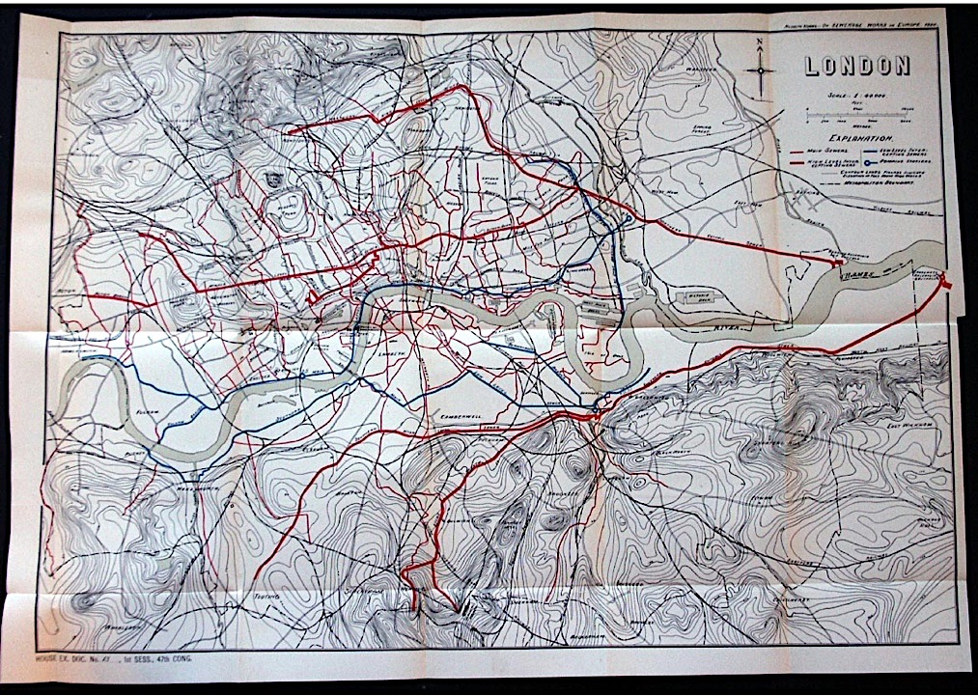

**Figure 1:** Sewage system of London, 1882 (Ancestry, 2016)

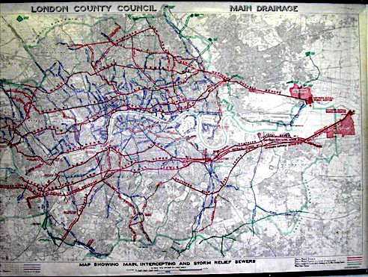

**Figure 2:** Drainage system of London, 1950s (H&H Geological Society, 2016)

# Objectives of the Cartography Lab

The main idea behind of this Cartography Lab is to create an interactive map based on the water management in Wellington, New Zealand.

Principally, the target audience is an extended group consisting of citizens, students but also specialized workers. The map will be Web-based and accessible to a broad public and it will provide a faster and easier way to graphically visualize the network and its properties. The final product will be published on the Web and it could potentially be linked to the City Council Web Site[1].

It is important to notice that the final product of this Cartography Lab is only a prototype. This means that we developed a lot of possible interaction between user and application but the content is extended only on storm water and waste water management.

# Basic data

The data have been downloaded from a NZ geoportal (<https://koordinates.com/>) from which the Shapefiles of the supply, drainage and treatment networks can be freely downloaded.

All the data are published using two licenses: the *CC BY-SA 3.0 (Attribution-ShareAlike 3.0 Unported)[2]* for basemap data such as DTM and municipality boundaries and the *CC BY-NC 3.0 NZ (Attribution-NonCommercial 3.0 New Zealand)[3]* for the data of the networks.

The content of the interactive map will be mainly based on two topics: the “Waste Water” and the “Rain Water” networks. Those are the two main parts of the content.

The two layers are supported by further information regarding: materials, diameter, slope, and year of construction (or maintenance).

The evolution of the networks in time can be easily observed by selecting a specific year with the time slider.

A DTM at 5 meter resolution was used to query the elevation at each point, the dTm was downloaded from the Koordinates portal.

The data of the basemap are the openstreet map data styled and used trough the mapbox interface.

# Technical equipment

The Map has been developed using the three key technology for web development: html , JavaScript and CSS.

Furthermore, a list of JavaScript libraries have been used:

* W2ui used to realize the GUI[4]
* JQuery. needed mostly for W2UI.js[5]
* Mapbox GL core library used for the visualisation of the cartographic data[6]
* Mapbox cartographic library based on Leaflet.js mostly used for the geocoder[7]
* Papa Parse to parse easily and efficiently csv text files.[8]
* NoUIslider for the creation of the time slider[9]

GDAL(Geospatial Data Abstraction Library) and python cgi script was used for the query the DTM for the elevation.

Mapbox studio was used for the design of the basemap.

Adobe illustrator and Inkscape were used for the manipulation of vector graphics.

The GIS software Qgis has used to preprocess, convert data to suitable format for the web.

Fortran code compiled with gfortran[10] has been used for the manipulation of text file.

During the whole development of the code the control version software Git[11] was used a repository was created on Git-Hub[12].

# Project steps and implementation

## 5.1 Data visualization

Two visualization mode of the network are implemented in the map.

An overview of the whole network ( see Fig *) is visible a higher zoom level (less than 14) here no semantical information is displayed and the geometrical content is displayed trough tiny line that allow the user to clearly see the basemap for orientation.

The second visualization mode appear at zoom closer than 14, here the pipes of the networks are categorized using two properties and two characteristic: line width for Diameter and color for the material.

Due the presence of numerous different material a semantical generalization was needed, it Tab * the semantical class and the different material belonging to each class are presented.

Table 1 Semantical classification of the Materials

|  |  |
| --- | --- |
| Class | Materials |
| Ceramics | Brick  Earthenware  Eare  Stoneware |
| Metals | Steel - spiral weld  Steel - epoxy lined  Steel - cement lined  Steel  Galvanised Steel  Galvanised Iron  Ductile Iron - cement lined  Ductile Iron  Copper  Cast Iron |
| Concrete | Reinforced Concrete  Concrete |
| Fibre composite | Pitch Fibre  Asbestos Cement |
| PVC plastics | uPVC  PVC - Blue Brute  Polyvinyl Chloride  mPVC |
| Polyethylene plastics | Polyethylene  Medium Density Polyethylene  High Pressure Polyethylene  High Density Polyethylene |
| Other , unknown | PLST  NPRN  NULL |

The conversion between Hydraulic Diameter and line width was done using the two following formulas:

* for the waste water network
* fot the storm water network

In the two formula the diameter (D) is given in mm and the resulting line width (LW) is in pixels.

The two formula were found with trial an error starting from the consideration that a linear scale is not probably suitable for the case due the big difference in the diameters (from 120 mm to more than 6000mm).

Since Mapbox GL do not allow styles based on continuous formula the diameters had to be categorize, the class chosen for the two networks are shown in Tab *.

Table 2 Categories for the diameter used

|  |  |
| --- | --- |
| Waste water network | Storm water network |
| 0 – 160 mm | 0 - 355 mm |
| 161 – 200 mm | 356 - 760 mm |
| 201 – 400 mm | 761 - 1530 mm |
| 401 – 800 mm | 1531 - 3500 mm |
| 801 - 2000 mm | 3501 - 6000 mm |

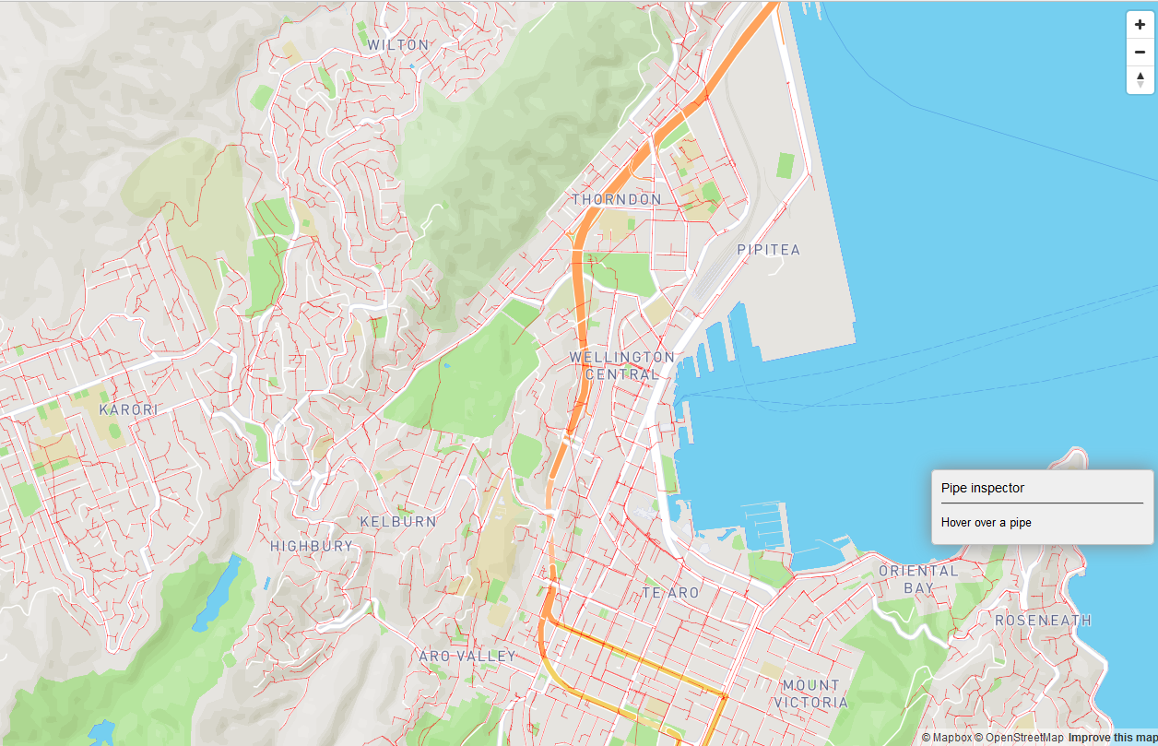

Figure overview visualisation mode

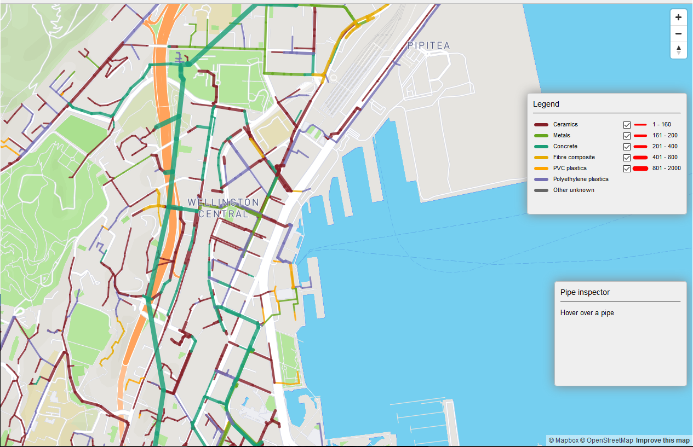

Figure 4 Categorized Visualization mode

## 5.2 Basemap choice

For the design of the basemap we consider including, useful information related to the water network such as:

* Street and street name (the water network is closely tight the the road one).
* Buildings
* Hillshading (give an overall impression of the topography)
* Contour lines for a better and quantitative understanding of the topography, showed only a closer zoom.
* Water bodies.
* A general landcover classification map.
* Label for the different neighbouroud of Welligton.

## 5.3 GUI design

## 5.4 Interactive Features

Different Interactive features are imbedded in the map, they are presented in this section:

### Geocoder

The geocoder integrated in the GUI allow the user to search for name of location inside the Wellington area, the resulting address are queried looking in the proximity of Wellington city center and excluded if they lay completely out of the bounding box of the city.

Once the result is clicked, the map is zoomed and panned to the location, an example of the results of a search is shown in Fig 6.

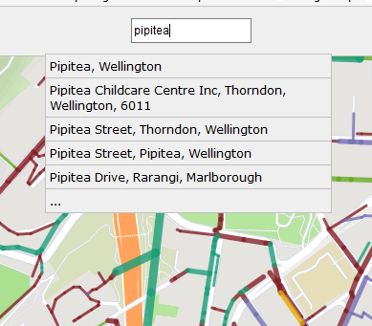

Figure 5 Geocoder example

### Pipe Inspector

The pipe inspector is a feature that allow the user to explore in details the properties of a pipe, when the user hover the mouse over a certain pipe a sketch with a section of the pipe and some important parameter such as Install date, detailed material, gradient, diameter(when the pipe is circular) or hydraulic diameter.

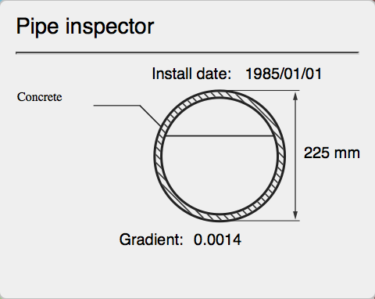

Figure 6 Pipe inspector

## Legend

The legend see Fig * is dynamical changed when switching between the networks. It can be visualized only if the network is not in the overview mode.

It allows checking or unchecking the visualization of pipes of different diameters.

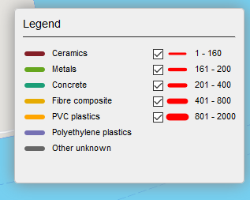

Figure 7 Legend for the waste water network

### Time slider

This feature is present only in the overview mode and allow the user select which timespan visualize on the map, in this way a technician can visualize which part of the network were installed or changed recently. The time slider is shown in Fig *.

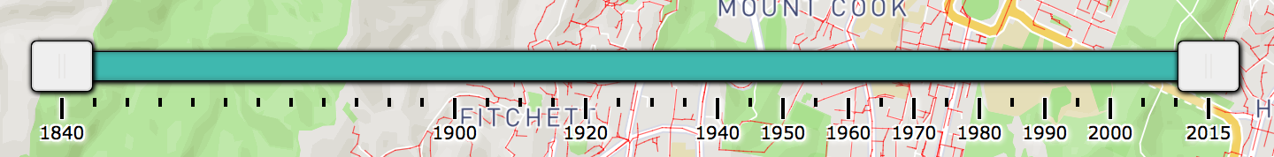

Figure Timeslider

### Flow Direction

This feature allow the user to see in which direction the water flow inside the pipes, the flow direction are shown using small arrow on top of the pipes. This features is enabled only after the zoom level 17 to prevent the map for arrow crowding, and example can be seen in Fig *.

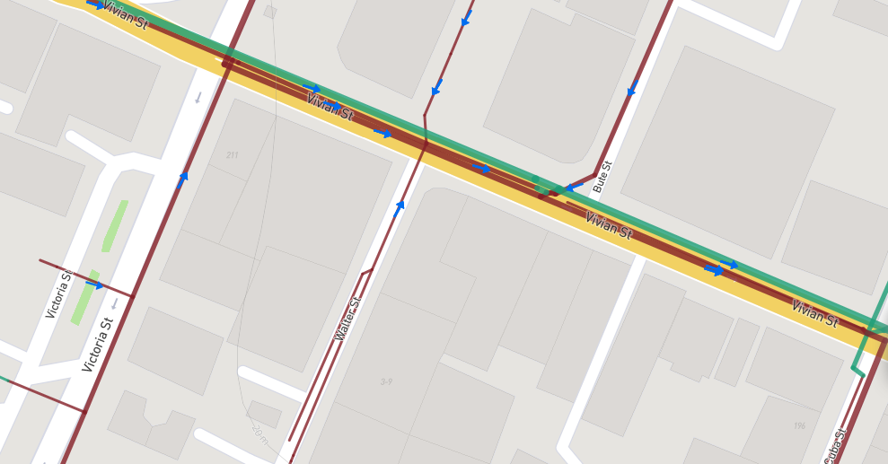

Figure 9 Flow direction

### Height query

This feature allow the user to query for the elevation in in wellington left clicking with the mouse in a point on the map. The value displayed is the corresponding pixel in the 5m resolution DTM of Wellington, the value is rounded at the decimeter.

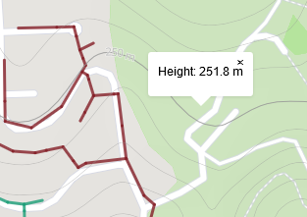

Figure Elevation query

# Results

# References

* Ancestry, 2016:

<http://freepages.genealogy.rootsweb.ancestry.com/~genmaps/genfiles/COU_files/ENG/LON/hering_lon-sewer_1882.html>

H&H Geological Society, 2016:

<http://www.hhgs.org.uk/monthly_meetings/previous_meetings/thames_tideway/thames_tideway.html>

1. **City Council Web Site**: http://wellington.govt.nz
2. # Source: http://creativecommons.org/licenses/by-sa/3.0/

  
3. # Source: http://creativecommons.org/licenses/by-nc/3.0/nz/

  
4. http://w2ui.com/web/
5. http://w2ui.com/web/
6. https://www.mapbox.com/mapbox-gl-js/api/
7. https://www.mapbox.com/mapbox.js/api/v2.4.0/
8. http://papaparse.com/
9. http://refreshless.com/nouislider/
10. https://gcc.gnu.org/wiki/GFortran
11. https://git-scm.com/
12. https://github.com/team1skyblueteo/Carto-Lab-Terroni